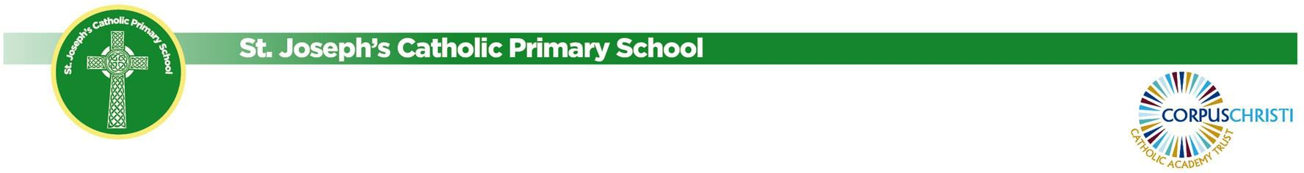

School Calendar 2024-2025

 | Pupils Start School | Pupils Finish School
Autumn Term | Wednesday 4th September | Friday 18th October 2024
 | Monday 28th October 2024 | Friday 20th December 2024
Spring Term | Monday 6th January 2025 | Friday 14th February 2025
 | Tuesday 25th February 2025 | Tuesday 8th April 2025
Summer Term | Tuesday 22nd April 2025 | Friday 23rd May 2025
 | Monday 9th June 2025 | Wednesday 23rd July 2025

In Service Days (children do not attend school)
Monday 2nd September 2024 | In Service Day
Tuesday 3rd September 2024 | In Service Day
Monday 24th February 2025 | In Service day
Thursday 24th July 2025 | In Service Day
Friday 25th July 2025 | In Service day
Monday 5th May 2025 | Bank Holiday (School Closed)

‘Where every child is known and loved, as a child of God’

