

St. Joseph’s Catholic Primary School

*“Where we learn to love and love to learn”*

# Behaviour and Engagement Policy 2024-2025

**Mission Statement**

Together at St. Joseph’s we learn to love,

Following Jesus, Sharing God’s gifts Building God’s world

|  |  |
| --- | --- |
| **Document Control** | |
| Name of Policy | Behaviour and Engagement |
| Date approved and adopted | January 2024 |
| Date to be reviewed | January 2025 |

Our vision at St Joseph’s Catholic Primary School is to provide a happy, secure environment with Christ at the centre of all we do. We aim to provide high standards of education and achievement for all of our pupils, in an environment where Catholic values are shared and lived by all. We aim to ensure that every child has the opportunity to realise their full potential in a positive, motivating and caring environment, where relationships are based on the values of respect, honesty, kindness and love. We aim to develop positive self-esteem in each child to encourage the best efforts, independence, self-reliance and responsibility for their own actions

The Behaviour and Engagement policy should allow us to build a framework from which to work that allows us to be consistent in our routines, support staff to build relationships, and provide appropriate and effective responses to children. We want our children to be happy, successful and included at all times. Our distinct nature as a Catholic school has informed this policy. This policy is in place to ensure a consistent approach from staff in dealing with incidents that arise in school so that any incidents that occur are dealt with in a just and timely manner.

Our ethos stems from an understanding that all behaviour is a form of communication and that it is the role of school staff, parents and carers to support the children in our care to communicate in a positive way by having their individual needs met.

**Aims and Objectives**

Through this policy, we aim to:

* create a warm, caring, calm and orderly atmosphere of belonging that positively promotes learning and a sense of community
* create an environment that is safe (physically and emotionally) for everyone to enjoy learning as part of a mutually supportive social group
* achieve consistency of attitude and response by staff which gives a sense of security
* promote and encourage the continual development of all staff in their understanding and working with children with social, emotional and mental health difficulties and review our practice regularly
* promote in all children, a sense of self-discipline, self-regulation, self-calming and an ability to take responsibility for their actions
* ensure each child feels safe in their ability to manage their emotions, feelings, behaviour and responses
* develop a partnership with parents/carers which recognises and respects important factors in the home life and experience of the child; through dialogue this supports parents to take a proactive and confident role in the management of their child’s behaviour and needs
* develop self-awareness and organised thinking skills
* To promote the importance of effective communication and the development of positive relationships
* To ensure that every member of the school community is treated fairly and inclusively, and feels valued and respected
* To help children grow and to become positive, responsible, confident and independent members of society
* To ensure that every child feels valued and has a strong sense of belonging in our school family

**Our policy and practice focus on:**

* Positive praise and reward
* Enabling and celebrating success
* Mutual respect
* Building self-esteem
* Developing a positive mental attitude through a growth mindset
* Providing good role-models
* Active listening
* Using positive language

**The Headteacher**

The Headteacher is responsible for reviewing this behaviour policy in-line with other policies. The Headteacher will also approve this policy. The Headteacher will ensure that the school environment encourages positive behaviour and that staff deal effectively with poor behaviour, and will monitor how staff implement this policy to ensure rewards and consequences are applied consistently.

**School Staff**

Staff are responsible for:

* + Implementing the behaviour policy consistently
  + Modelling positive behaviour
  + Providing a personalised approach to the specific behavioural needs of particular pupils
  + Recording serious behaviour incidents on CPOMS

The Senior Leadership Team will support staff in responding to behavior incidents.

**Parents**

Parents are expected to:

* + Support their child in adhering to our School Rules
  + Inform the school of any changes in circumstances that may affect their child’s behaviour
  + Discuss any behavioural concerns with the class teacher promptly

**Staff Development, Induction & Support**

We prioritise training at least termly for staff on the behaviour policy, and where appropriate, we will implement a curriculum response to address poor behaviour choices. When staff join our school team, they will be provided with a copy of the policy to read and be included in update training throughout the year.

**Links with other policies**

* + Anti-bullying policy
  + Exclusions policy
  + Equality policy
  + Relationships policy
  + SEND policy and Information Report
  + Safeguarding policy
  + RSE
  + Positive Handling and Physical Intervention policy

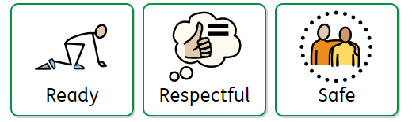

**Be ready. Be respectful. Be safe.**

All pupils understand that if the three golden rules are followed, **everyone** *can learn to love and love to learn*. The three rules are displayed across school, read in assembly and repeated in classrooms at the beginning of the day.

|  |  |  |
| --- | --- | --- |
|  | Staff at St Joseph’s strive to be:  Relentlessly positive with high expectations for all. Proactive in establishing strong, clear routines.  Passionate about praising positive behaviour to make pupils feel noticed. | |
| If a child is not being ready, respectful or safe, the following processes are used:  *If there are incidents of dysregulated violent behaviour, children must go to step 4 and if their behaviour continues to endanger the safety of themselves,  children or adults then they must be sent to a member of SLT who will decide on an appropriate sanction (missing of whole playtimes or lunchtimes) depending on the severity of the behaviour. | | |
| 1.Redirect | Staff will use – eye contact, pointing to redirect children to positive choices.  Positive reinforcement of other children around them. | |
| 2.Remind | Staff will give a verbal reminder of three rules Children will be given clear direction, using a scripted response  Pupil has a choice to do the right thing (Give take up time) **Staff will praise any positive change** | |
| 3.Think  **Pupil will be given a verbal warming**  The pupil will be made aware of their behaviour and given a clear outline of consequence if they continue via a scripted conversation. | Our Script:   1. I notice you are… 2. You know our rule about… 3. I expect to see… 4. Remember when you… 5. Thank you for listening. | |
| 4. Reflect | If behaviour continues, the pupil will be given a time out (minutes dictated by age of the child) in their partner class within a designated area. This incident will be recorded.  Pupils may need to regulate (use sheet for calming down strategies) and reflect (draw or write on reflection sheet). | |
| 5. Repair | 1. What happened? 2. What were you thinking/   feeling at the time?   1. Who was affected by what   you did? How? | 1. How are you feeling now? 2. What could you have done   differently?   1. **What needs to be done to put things right?** |

All teachers have **‘think** and **‘reflect’** cards to present to children when needed after redirection has been given.

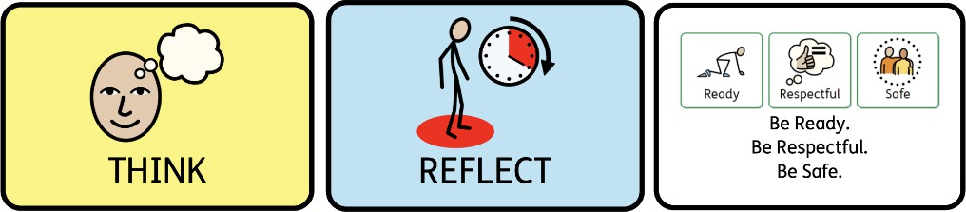

For unacceptable behaviour, show a **think** card where the child has to **think** about their behaviour using a **script** if required.

For continued unacceptable behaviour, show the **‘reflection’** card. **Pupil to have a timed (minutes dictated by the age of the child) ‘reflection’ in their linked classroom using an age and phase appropriate reflection sheet.**

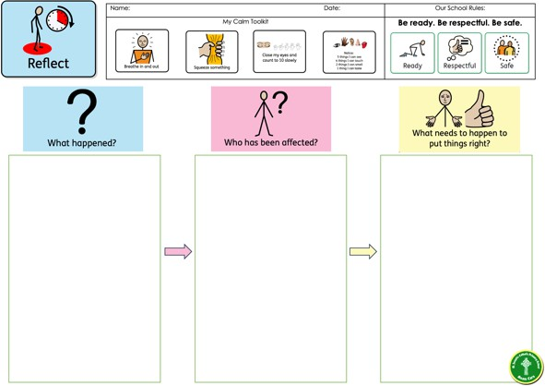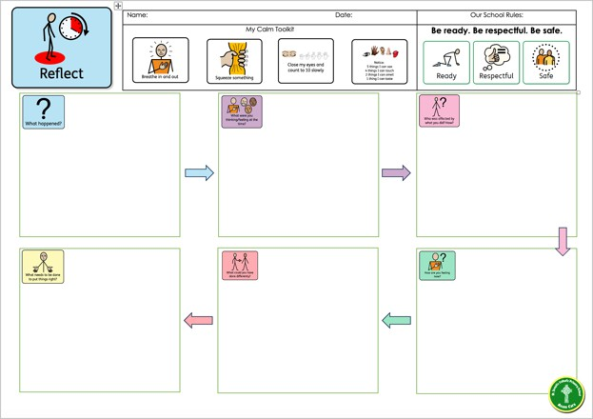

|  |
| --- |
| **Linked Classrooms** |
| Y3/4 RA Y5/6 KH |
| Y5/6 KH  Y3/4 RA |
| Y1/2 EM  EYFS |
| EYFS are to stay in their own classroom but access a calm space soft space to regulate and reflect. |

* After a ‘Reflection’ the child re-enters the classroom – a conversation with the class teacher needs to take place as soon as possible after their return.
* De-escalation techniques should be used for non-compliance.
* At the end of the day a **standard letter** will be sent home informing parents of the ‘Reflection’.

(Appendix B)

#### Any ‘Reflection’ will be recorded by the class teacher on CPOMS.

* If a child moves to ‘Reflection’ more than twice in a day, further action needs to be taken. There

will be a phone call home to inform parents of this.

* The number of ‘Reflections’ given will be closely monitored.

|  |  |
| --- | --- |
| Rewards | Sanctions |
| Verbal Praise | Redirect |
| Dojo Points | Remind |
| Superstar Board | Think |
| Share success with school.  (stickers/reward from SLT.) | Reflect |
| Share success with home  (contact with parents phone call/postcard home) | Repair |

In addition, a member of each class will receive a celebration certificate in our weekly Celebration Assembly.

To be selected for this award children must have showcased how they have lived the school mission during the week.

e.g.

improving friendship skills Beautiful English work

For embracing new challenges.

For passion and curiosity in all lessons

***Dojo System***

Dojo points are awarded to children for many reasons to promote positive behaviour and attitudes. All classes will reward children for positive behaviour in the following categories:

* Effort
* Behaviour in the Classroom
* Behaviour around School
* Homework
* Correct Uniform & PE Kit

Some examples of how to award dojo points are provided below:

### Positive Behaviour:

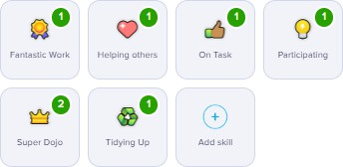

Other behaviours may be added depending on the individual needs of the class. The ‘Needs Work’ button is not used to remove Dojo points.

### Attendance & Punctuality

Children get a dojo every day that they are in.

Children are in four house teams per class and will gather team points each week. The team at the end of each week with the most points will be celebrated in Celebration assembly on a Friday. **Dojos must be reset every Monday.**



Each class has a ‘Superstar Board’

*Staff at St Joseph’s strive to be: Relentlessly positive with high expectations for all. Proactive in establishing strong, clear routines. Passionate about praising positive behaviour to make pupils feel noticed.*

Class Teacher’s aim to recognise each child in their class with positive praise each day and add their picture to the Superstar Board.

Once a child has been added to the Superstar board, their name cannot be removed.

### Unacceptable Sanctions

All adults will act as a role model and will **speak to the children in a calm manner** at all times. The following sanctions are not acceptable at St Joseph’s Catholic Primary School.

* Writing lines.
* Writing the children's names on boards or displays to indicate a sanction or warning.
* Sending children to stand outside of a classroom or against walls on the playground.
* Removing rewards previously given to children for positive behaviour.

### Behaviour Outside of the Classroom

Our behaviour system **must** also apply to poor behaviour at playtime, in the corridor and during assemblies. All teachers must report incidents that they have dealt with to the class teacher so that pupil behaviour is monitored and they are not causing disruptions at other times of the day. Children who choose to break the 3 rules, will have to miss some of their lunchtime play the following day using the restorative sheet. Parents/carers will be notified. Any part of lunchtime play missed, will be recorded on CPOMS

|  |  |
| --- | --- |
| **Behaviours we encourage:** | **Unacceptable behaviour includes:** |
| * Respect for other people, their views and their work * Attentiveness * A sense of right and wrong * Self-respect * Respect for the environment * Working cooperatively * Honesty and trust * Fairness * Self-discipline * Politeness and good manners * Setting a good example to others | Racial harassment   * Violence and aggression * Intentionally hurting other people’s feelings * Threatening behaviour including bullying * Dishonesty * Deliberate disobedience * Discrimination * Lack of respect * Using unacceptable language * Deliberately damaging property * Disrupting teaching and learning * Taking things that do not belong to us |

### Arrangements for Exclusion

**Step 1 (Headteacher) Internal Exclusion** (up to 5 days)

* Child has no contact with own class or classmates.
* No access to playground at the same time as other children, extra-curricular or enrichment activities.
* Parents, Chair of Pupil Discipline Committee,

## If behaviour improves return to class on a Behaviour Contract. If not move to **Step 2.**

**Step 2 (Headteacher) Fixed Short Term Exclusion** (up to 5 days per term)

* Parents and Chair of Pupil Discipline Committee informed.
* This is recorded in SIMs and collected through the termly census.
* Parents may make representations to Pupil Discipline Committee.
* Pupil Discipline Committee may meet but cannot reinstate.
* Upon return to school, child stays on Contract for a minimum of 2 weeks.
* ​

## If behaviour improves remove from Behaviour Contract. If not move to **Step 3.**

**Step 3 (Headteacher) Fixed Long Term Exclusion** (up to 45 days per year).

* Parents, Chair and Clerk of Discipline Committee informed.
* This is recorded in SIMs and collected through the termly census.
* Discipline Committee meet (parents/child or representative may attend/make representations).
* Discipline Committee either reinstate or uphold the exclusion.
* Upon return to school or if reinstated child stays on Contract or PSP for a minimum of 10 weeks.

## If behaviour improves remove from PSP. If not move to **Step 4**.

* ​

### Step 4 (Pupil Discipline Committee) Permanent Exclusion

* Parents, Chair and Clerk of Discipline Committee informed.
* This is recorded in SIMs and collected through the termly census.
* Discipline Committee meet and consider all representations and reports (parents/child may attend).
* Discipline Committee either reinstate or uphold exclusion.
* Parents notified of right to appeal.
* If appeal successful, or reinstated child stays on Contract or PSP for the maximum 20 weeks.
* If appeal unsuccessful, remove child from school roll.

Serious incidents need to be treated on an individual basis and the circumstances investigated.

In exceptional circumstances permanent exclusion may be considered for a first or ‘one off’

offence. These may include:

* Serious actual or threatened violence against another pupil or a member of staff;
* Sexual abuse or assault;
* Supplying an illegal drug;
* Carrying an offensive weapon;
* Serious deliberate damage to school property.

#### Strategies

Provide frequent, descriptive, specific, proximate praise for good behaviour at every opportunity for all children by focusing on opportunities where positive behaviour is shown as opposed to focusing on correcting behaviour.

Use of the school’s RWI actions (see appendix A) to ensure a consistent approach across the school. Staff teach ‘from feet’ (i.e. standing or moving) to show the importance of the lesson being taught. Meet, greet and connect with children at the classroom door as they enter each morning.

Focus on the children at all times to give attention to desired behaviour.

Adhere to the school’s Positive Playtimes arrangements in order to support behaviour during transition times and periods of less structured activity.

Be firm yet fair and create clear boundaries and routines quickly to ensure children are clear of expectations,

referring frequently to the school’s golden rules.

Promote a calm, orderly environment in all areas of the school.

Engage with children and show interest to promote a sense of belonging.

Ensure the focus of each lesson is on teaching and learning and managing low-level behaviour which in turn keeps an engaging pace.

Set a clear routine each day to ensure children are aware of expectations and know what will be happening next through the use of a visual timetable.

Promote safety for all members of the school through responsible and appropriate behaviour.

Liaise with the Behaviour Lead, SENDCo, SLT and parents regarding behaviour concerns and develop strategies to support behaviour development.

Keep an accurate record of repeated behavioural incidences using CPOMS. Reward children for desirable behaviour using the whole school reward systems.

Fully investigate any situations between children before referring to co-teachers and SLT. Investigations should take place using the Restorative Justice discussion resource, which addresses the following questions and includes visual aids:

#### Children with Special Educational Needs and Disability (SEND) and Wellbeing Needs

We recognise that some children have specific needs with regards to their behaviour. For those identified with SEND, LAC, or those with social, emotional and mental health issues the system may be altered and adapted to meet their needs. Some children may have such specialised needs that the above measures are wholly inappropriate. In these circumstances specialist advice is sought and the system is modified for the individual.

#### The Impact of Trauma on Behaviour

Children who have been exposed to trauma can have considerable reactions that can interfere with learning and behaviour. They often find it difficult to concentrate, which impacts upon their ability to learn, resulting in low self-esteem. They can display attention-needing behaviours, which can often be disruptive, and may be physically and verbally abusive. Understanding and sensitively responding to the unique needs and behaviours of all children is integral to creating a positive and inclusive learning environment. We aim to support children who have experienced trauma through personalised strategies.

#### Parental Responsibilities

Positive home-school communication is imperative to the promotion of positive behaviour. Parents and carers should engage openly, honestly and proactively about their child’s behaviours and welfare at home and anything that might be impacting upon them, as well as ensuring that children attend school in good health, punctually and regularly. The class teacher should be the first point of contact for parents.

#### Child-on-Child Abuse

**Child-on-child sexual violence and assault is not accepted and will never be tolerated.** All incidents of child-on-child abuse will be referred to the Designated Safeguarding Lead, who will advise on the most appropriate course of action in the given circumstances. All inappropriate language and behaviour between pupils will be challenged by staff.

#### Written: January 2024 Agreed:

**To be reviewed: January 2025**

Appendix A:

|  |  |
| --- | --- |
| As a RWI school the following silent signals are used school wide to promote high standards of learning behaviour. | |
|  | The team stop signal helps staff to stop pupils in a  calm manner, ready for what’s next.  The stop signal is used in assembly, in lessons, during transitions, at lunchtime, on trips and in staff meetings.  The signal to gain attention.   1. Staff will hold one hand in the air with a flat palm. 2. Staff scan the room to check every pupil has responded. Every pupil:    * raises one hand in response;    * checks their partner and others at their table have also raised their hands – gently tapping an arm if necessary;    * looks attentively at staff –to show they are ready to listen.   3. Staff lower their hand and scan to check everyone is looking at them attentively, ready to listen. Staff do not start talking until they have their attention. |
|  | When staff need to ensure that pupils are listening, they will point to their eyes with two fingers. This indicates that their eyes should be facing the front and their bodies should be ready to learn.*  *Reasonable adjustments are made for neurodiverse children. |
|  |  |
| **My Turn Your Turn**  This is a silent signal staff use when they want pupils to repeat something after them. My turn: staff gesture towards themselves with one or two hands. Your turn: staff gesture towards the pupils with one or two open palms. | **Talk to Your Partner**  Partner work is used consistently in all lessons to allow all children to work collaboratively and have their voices heard.  Staff hold both hands pointing forward as if they are two open gates. Staff close the gates as soon as they have finished asking the question.  This signal is practised until pupils turn automatically to their partners to answer the question. |

Append

# St. Joseph's Catholic Primary School



ix B:

-

- - - - - -



Date:

Dear Parent/ Carer,

Your child behaviour today has not been in line with our school rules.

Your child was

Due to this behaviour, your child received a 'reflection' in another classroom for minutes. Your child's behaviour will be closely monitored so disruption is not caused again.

Pllease speak to your child about their behaviour today and if it continues, you will be invited into school to discuss your child's behaviour.

I would appreciate it if you could return the slip below to show you have received and read this letter.

Thank you for your cooperation. Your sincerelly,

Mrs A. Reeh Headteacher

I have received the letter that has informed me about my child's reflection and have discussed their behaviour at home.

Signed

Date: _

**Where every child is known and loved, as a child of God**

St Joseph's Catholic Primary School. Etchells St, St Petersgate, Stockport, SK11EF.

Telephone: 0161 480 5029 Email: [admin@st-josephs-pri.stockport.sch.uk](mailto:admin@st-josephs-pri.stockport.sch.uk) Website: [www.st-josephs-pri.stockport.sch.uk](http://www.st-josephs-pri.stockport.sch.uk/)

**Mrs A. Reeh, Headteaother.**