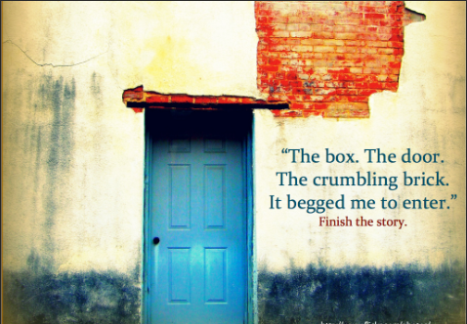

Finish the story. What do you find on the other side of the door? How do you feel? How did you come across this door? What building does it belong to?
Use the above questions to help you plan and write an ending to this story. Use a range of features including parenthesis, powerful vocabulary, fronted adverbials and modal verbs.
……………………………………………………………………………………………………………………………………………………………………………………………………………………………………………………………………………………………………………………………………………………………………………………………………………………………………………………………………………………………………………………………………………………………………………………………………………………………………………………………………………………………………………………………………………………………………………………………………………………………………………………………………………………………………………………………………………………………………………………………………………………………………………………………………………………………………………………………………………………………………………………………………………………………………………………………………………………………………………………………………………………………………………………………………………………………………………………………………………………………………………………………………………………………………………………………………………………………………………………………………………………………………………………………………………………………………………………………………………………………………………………………………………………………………………………………………………………………………………………………………………………………………………………………………………………………………………………………………………………………………………………………………………………………………………………………………………………………………………………………………………………………………………………………………………………………………………………………………………………………………………………………………………………………………………………………………………………………………………………………………………………………………………………………………………………………………………………………………………………………………………………………………………………………………………………………………………………………………………………………………………………………………………………………………………………………………………………………………………………………………………………………………………………………………………………………………………………………………………………………………………………………………………………………………………………………………………………………………………………………………………………………………………………………………………………………………………………………………………………………………………………………………………………………………………………………………………………………………………………………………………………………………………………………………………………………….

