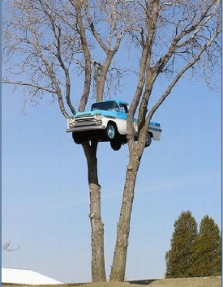

How did the car end up between the trees? Use your imagination to write a short story about this picture.
…………………………………………………………………………………………………………………………………………………………………………………………………………………………………………………………………………………………………………………………………………………………………………………………………………………………………………………………………………………………………………………………………………………………………………………………………………………………………………………………………………………………………………………………………………………………………………………………………………………………………………………………………………………………………………………………………………………………………………………………………………………………………………………………………………………………………………………………………………………………………………………………………………………………………………………………………………………………………………………………………………………………………………………………………………………………………………………………………………………………………………………………………………………………………………………………………………………………………………………………………………………………………………………………………………………………………………………………………………………………………………………………………………………………………………………………………………………………………………………………………………………………………………………………………………………………………………………………………………………………………………………………………………………………………………………………………………………………………………………………………………………………………………………………………………………………………………………………………………………………………………………………………………………………………………………………………………………………………………………………………………………………………………………………………………………………………………………………………………………………………………………………………………………………………………………………………………………………………………………………………………………………………………………………………………………………………………………………………………………………………………………………………………………………………………………………………………………………………………………………………………………………………………………………………………………………………………………………………………………………………………………………………………………………………………………………………………………………………………………………………………………………………………………………………………………………………………………………………………………………………………………………………………………………………………………………………………………………………………………………………………………………………………………………………………………………………………………………………………………………………………………………………………………………………………………………………………………………………………………………………………………………………………………………………………………………………………………………………………………………………………………………………………………………………………………….

