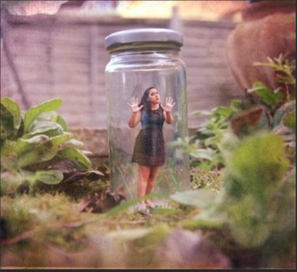

How did the girl end up in the jar? Who put her there and why? Write a short creative story about this picture using features we have covered so far this year. Use your SPaG word definition map to help you.
……………………………………………………………………………………………………………………………………………………………………………………………………………………………………………………………………………………………………………………………………………………………………………………………………………………………………………………………………………………………………………………………………………………………………………………………………………………………………………………………………………………………………………………………………………………………………………………………………………………………………………………………………………………………………………………………………………………………………………………………………………………………………………………………………………………………………………………………………………………………………………………………………………………………………………………………………………………………………………………………………………………………………………………………………………………………………………………………………………………………………………………………………………………………………………………………………………………………………………………………………………………………………………………………………………………………………………………………………………………………………………………………………………………………………………………………………………………………………………………………………………………………………………………………………………………………………………………………………………………………………………………………………………………………………………………………………………………………………………………………………………………………………………………………………………………………………………………………………………………………………………………………………………………………………………………………………………………………………………………………………………………………………………………………………………………………………………………………………………………………………………………………………………………………………………………………………………………………………………………………………………………………………………………………………………………………………………………………………………………………………………………………………………………………………………………………………………………………………………………………………………………………………………………………………………………………………………………………………………………………………………………………………………………………………………………………………………………………………………………………………………………………………………………………………………………………………………………………………………………………………………………………………………………………………………………………………………………………………………………………………………………………………………………………………………………………………………………………………………………………………………………………………………………………………………………………………………………………………………………………………………………………………………………………………………………….

